CSA1708-ARTIFICIAL INTELLIGENCE
LAB EXPERIMENTS
Program 18 : Prolog Program for a Database with Name and Date of Birth
Aim
To create a Prolog database that stores names and dates of birth and retrieves a person's birth date.
Algorithm
1. Add person facts containing a name and a date(day, month, year) value.
2. Define a rule that matches a name with its date fields.
3. Query the rule with a name and variables for the day, month, and year.
4. Read the values returned by Prolog.
Program
person(aarav, date(12, 5, 2004)).
person(priya, date(3, 9, 2003)).
person(rahul, date(21, 1, 2005)).
person(sneha, date(8, 12, 2004)).
birth_date(Name, Day, Month, Year) :-
person(Name, date(Day, Month, Year)).
Sample Input
?- birth_date(priya, Day, Month, Year).
Program Execution
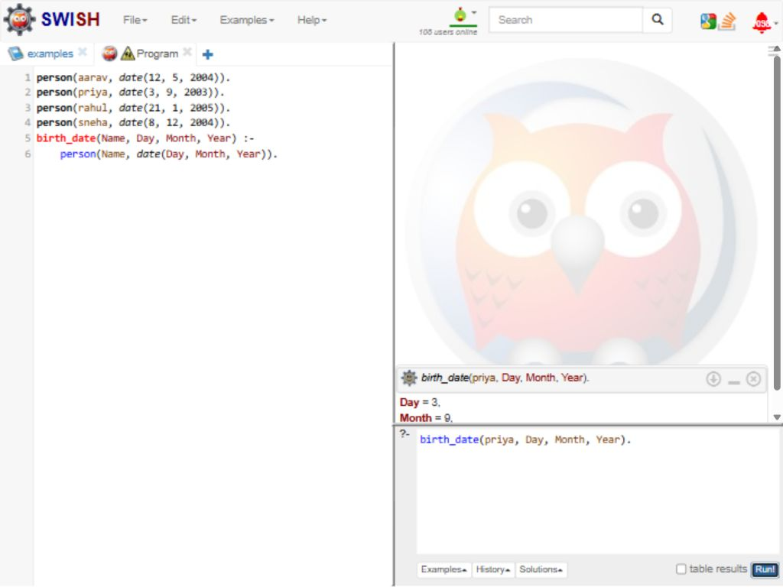
RESULT
Thus, the Prolog database stored names and dates of birth and returned Priya's birth date as 3 September 2003.

